

Version: v1.0

Author: Sridhar Kannan

TFL – Test-Driven Development Document

Created date: 16/09/2023

Contents

1. Introduction 3

1.1 Purpose of the document 3

1.2 Scope 3

1.3 Scenario description 3

2. Requirements 3

2.1 Purpose of the document 4

2.2 Roles and Responsibilities 4

3. Use Cases 4

3.1 Use Case 1: Create Contact and Case 4

3.2 Use Case 2: Classify Case 5

3.3 Use Case 3: Attach Picture Evidence 5

3.4 Use Case 4: Assign Case to Manager 5

3.5 Use Case 5: Resolve Case 5

3.6 Use Case 6: Escalate Case 5

3.7 Use Case 7: Handle Confidential Cases 5

4. Access Control 5

4.1 User Roles and Permissions 5

4.2 Access Control Rules 5

5. Customization 6

6. Test Case 6

6.1 User Roles 6

6.2 Access Control 6

6.3 Manager Resolution 7

6.4 Manager Follow-Up Activity 7

6.5 Confidential Cases 9

7. Conclusion 9

1. Introduction
   1. Purpose of the document

This Test-Driven Development (TDD) document aims to provide a comprehensive guide for developing and testing the Dynamics CRM system to manage enquiries, complaints, and follow-up actions within our Contact Centre and Operation.

* 1. Scope

This document covers the requirements, use cases, access control, and customization details for the Dynamics CRM system. It outlines the expected behaviour and functionality of the system based on the specified requirements.

* 1. Scenario description

As part of our Contact Centre and Operation, the business has requested the development of a process to manage enquiries, complaints, and tracking of follow-up actions in Dynamics CRM. The process involves creating and managing contacts, cases, and classifying cases based on the type of incident. Users in different roles will have specific access and customization rights to handle these cases effectively. There are three contact centres, each responsible for managing cases related to Underground, Buses, and Overground transportation, respectively.

1. Requirements
   1. Purpose of the document

The following types of requirements are identified for this project:

* **Access Requirements**

Users should only access cases allocated to their respective contact centres. Agents should create contacts, cases, and classify cases.

* **Customization Requirements**

Managers can resolve cases. If a manager cannot resolve a case, they must create and send a follow-up activity that includes all case-related information, contacts, and activity documents to the Escalation Team. If an agent marks a case as confidential, the manager must create/send a follow-up activity containing all information to the Confidential Case Team.

* 1. Roles and Responsibilities

The following types of requirements are identified for this project:

* **Customer Service Agent**

Responsible for receiving calls and classifying cases.

* **Customer Service Manager**

Responsible for resolving cases or handing off cases for further information.

* **Escalation Team**

Responsible for providing more information or possible resolutions.

* **Confidential Case Team**

Handles confidential Follow-up activities.

1. Use Cases
   1. Use Case 1: Create Contact and Case

**Description:** Agents should be able to create contacts and cases.

* 1. Use Case 2: Classify Case

**Description**: Agents should be able to classify cases based on the nature of the incident.

* 1. Use Case 3: Attach Picture Evidence

**Description**: Users can attach picture evidence of the incident to contacts, cases, or activities to assist in case investigation.

* 1. Use Case 4: Assign Case to Manager

**Description**: Cases should be assignable to managers for resolution.

* 1. Use Case 5: Resolve Case

**Description**: Only managers can resolve cases.

* 1. Use Case 6: Escalate Case

**Description**: If a manager cannot resolve a case, they should create and send a follow-up activity containing all related information to the Escalation Team.

* 1. Use Case 7: Handle Confidential Cases

**Description**: If an agent marks a case as confidential, the manager will create/send a follow-up activity containing all information to the Confidential Case Team. This activity should only be visible to the manager and the Confidential Case Team.

1. Access Control
   1. User Roles and Permissions

• **Customer Service Agent**: Create contacts and cases, classify cases.

• **Customer Service Manager**: Resolve cases, create/send follow-up activities.

• **Escalation Team**: Receive follow-up activities, provide additional information or resolutions.

• **Confidential Case Team**: Receive confidential follow-up activities.

4.2 Access Control Rules

• Users can only access cases assigned to their contact centre.

Only Managers can resolve cases.

• If a manager cannot resolve a case, they send follow-up activities to the Escalation Team.

• If an agent marks a case as confidential, the manager sends follow-up activities to the Confidential Case Team, which is only visible to the manager and the Confidential Case Team.

1. Customization

• Only Managers should have the ability to resolve cases.

• If a manager cannot resolve a case, they must create and send follow-up activities to the Escalation Team.

• If an agent marks a case as confidential, the manager must create/send follow-up activities to the Confidential Case Team, which should be accessible only by the manager and the Confidential Case Team.

1. Test Case

6.1 User Roles

**Test Case 1**: Verify that users have the correct roles assigned and able to view customer service hub (app).

• **Test Steps**:

1. Verify that a Customer Service Agent has the "Customer Service Agent" role.
2. Verify that a Customer Service Manager has the "Customer Service Manager" role.
3. Verify that an Escalation Team member has added to the "Escalation Team" of that Contact Centre (BU) and the "Escalation Team" role assigned to the Team.
4. Verify that a Confidential Case Team member has added to the "Confidential Case Team" of that Contact Centre (BU) and the "Confidential Case Team" role.

• **Expected Result**: Each user and team should have the appropriate role assigned.

6.2 Access Control

**Test Case 2**: Verify that users can only access cases allocated to their contact centre.

• **Test Steps**:

1. Log in as a Customer Service Agent from Contact Centre (Underground).
2. Attempt to access cases from Contact Centre (Buses) and Contact Centre (Overground).

• **Expected Result**: The agent should only be able to access cases allocated to Contact Centre (Underground).

**Test Case 3**: Verify that a Customer Service Agent can create a contact, create a case, and classify it.

• **Test Steps**:

1. Log in as a Customer Service Agent.
2. Create a new contact.
3. Create a new case and classify it.

• **Expected Result**: The agent should be able to create a contact and case and successfully classify it.

6.3 Manager Resolution

**Test Case 4**: Verify that only a manager can resolve a case.

• **Test Steps**:

1. Log in as a Customer Service Manager.
2. Attempt to resolve a case.
3. Log in as a Customer Service Agent and attempt to resolve a case.

• **Expected Result**: Only the manager should be able to resolve a case.

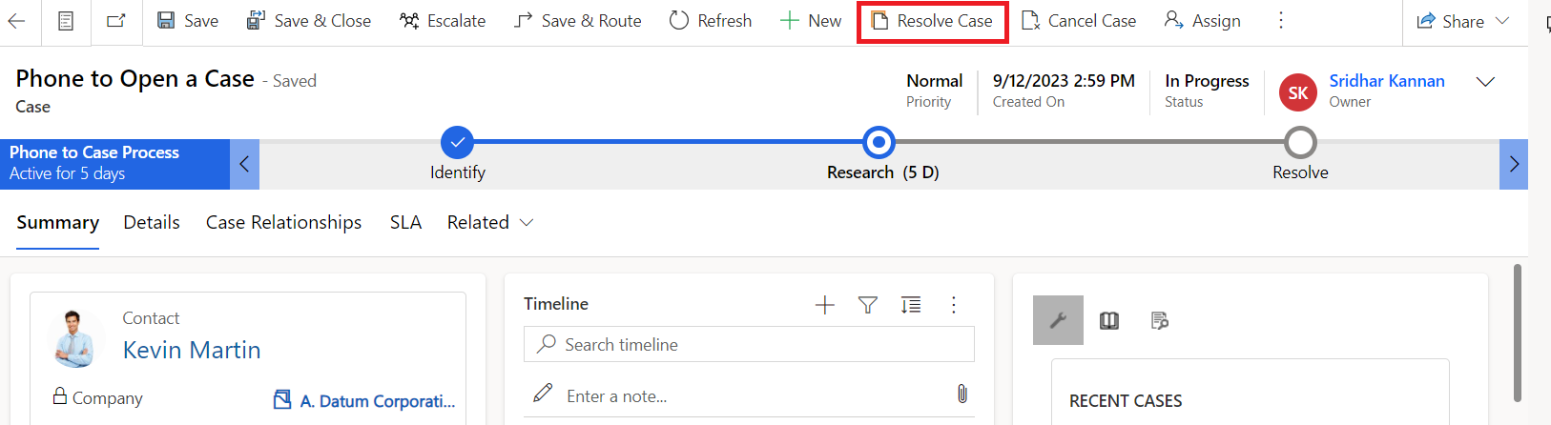

6.4 Manager Follow-Up Activity

**Test Case 5**: Verify that if a manager cannot resolve a case, they can create and send a follow-up activity with all related information.

• **Test Steps**:

1. Log in as a Customer Service Manager.
2. Attempt to resolve a case but fail to do so.
3. Escalate the Case by selecting the "Escalation Team" (of that contact centre e.g., Escalation Team-Underground) in the "team" field of case and click escalate button.

• **Expected Result**: The manager should be able to select the team of that contact centre and should have access to escalate button. When clicked, an email will be created against the case with Escalation Team email template (contains case and contact information) and will include all documents (case, contact and related activities). This email will be sent to the "Escalation Team" (queue email).

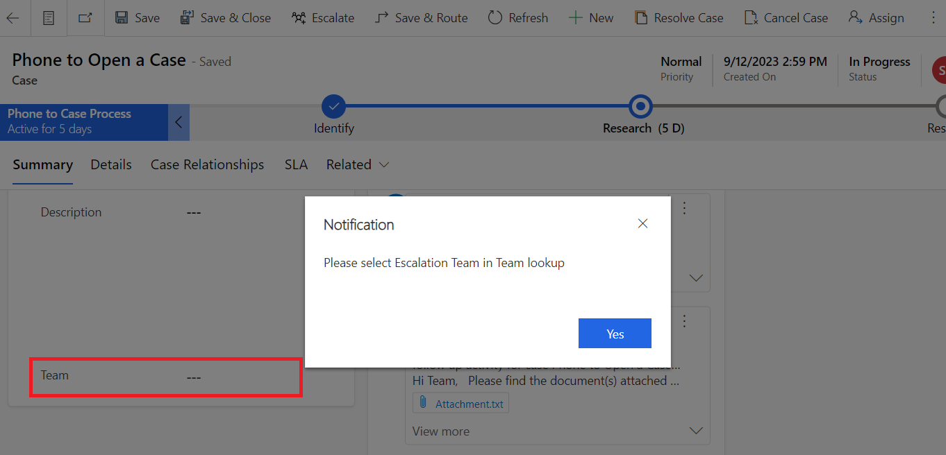

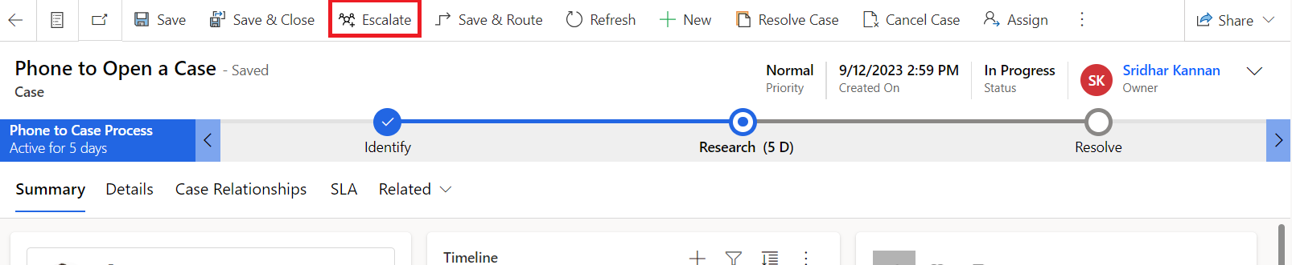

6.5 Confidential Cases

**Test Case 6**: Verify that if an agent marks a case as confidential, the manager can create/send a follow-up activity to the Confidential Case Team.

• **Test Steps**:

1. Log in as a Customer Service Agent.
2. Create a case and mark it as confidential.
3. Log in as a Customer Service Manager.
4. Attempt to resolve the confidential case but fail to do so.
5. Escalate the Case by selecting the "Confidential Case Team" (of that contact centre e.g., Confidential Case Team-Underground) in the "team" field of case and click escalate button Create to send a follow-up activity.

• **Expected Result**: The manager should be able to select the team of that contact centre and should have access to escalate button. When clicked, an email will be created against the case with Confidential Case Team email template (contains case and contact information) and will include all documents (case, contact and related activities). This email will be sent to the "Confidential Case Team" (queue email) and only the manager and confidential team can view it.

**Test Case 7**: Verify that if the confidential email is visible only to that Manager and Confidential Case Team of that contact centre (BU).

• **Test Steps**:

1. Log in as a Customer Service Agent and check if the confidential email is visible.
2. Log in as a Customer Service Manager and check if the confidential email is visible.
3. Log in as an Escalation Team member and check if the confidential email is visible.
4. Log in as a Confidential Case Team member and check if the confidential email is visible.

• **Expected Result**: The confidential email should be visible only to that manager and confidential case team.

1. Conclusion

This document outlines the requirements, use cases, access control, and customization details for implementing the Dynamics CRM system to manage enquiries, complaints, and follow-up actions within the Contact Centre and Operation. Also, outlines specific test cases to verify that the Dynamics CRM system meets the stated requirements. You can expand upon these test cases with more detailed steps and expected results as needed.